ME149 Proposal Shane Rozen-Levy

The dynamical system I am working with is a robot car. The car will have a rear wheel drive powered by a DC motor. The front axel of the car will yaw, allowing the car to steer. The steering will be controlled by a standard servo. The dynamics for this system are in Eric Moret’s thesis.

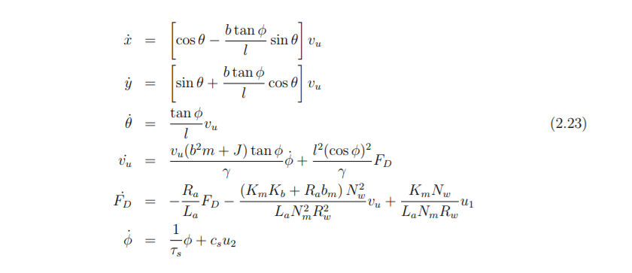

I will solve 2 different optimization problems based on common maneuvers a car might make. I will model the car turning around on a narrow road and parallel parking in a tight spot. I will have boundary constraints so the car starts and ends where I want it to, path constraints on the control input so the dynamics of the DC motor do not change with high voltages, and path constraints to ensure that the car does not hit any objects. The final path constraint will be difficult to model in a smooth manner. For parallel parking I will model the car as a few circles and the other cars as a few circles. For turning around, I will check to make sure the corners of the car are within the bounds of the sides of the road.

The objective function will be a weighted sum of minimum \dot{u1}^2, and shortest time.

I plan to use trapezoidal collocation.

Advanced techniques:

* 1. Constraints not seen in class
  2. Objective function not used in hw
  3. Dynamical system not found in code library
  4. Implement tracking controller

My hope is that in conjunction with Dominic and Liangchun we can make a physical version of this robot, and test our trajectories on the robot. The project will be done individually, but the robot will be made as a group

Eric N Moret, Dynamic Modeling and Control of a Car-Like Robot

<http://citeseerx.ist.psu.edu/viewdoc/download?doi=10.1.1.2.6994&rep=rep1&type=pdf>